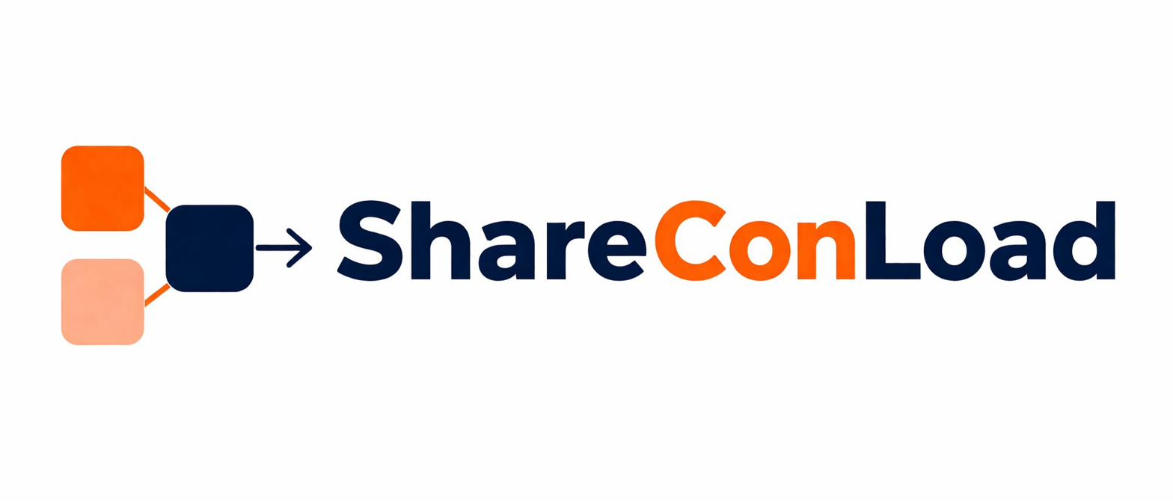
TERMS & CONDITIONS
ShareConLoad Digital Logistics Marketplace
Effective Date: [Insert Date]
These Terms & Conditions ("Terms") govern the use of the ShareConLoad platform and services operated by VEYQON GROUP (Pty) Ltd, registration number 2026/353683/07, a company registered in the Republic of South Africa. By accessing or using the Platform, you agree to be bound by these Terms.

1. DEFINITIONS
For purposes of these Terms, the following definitions shall apply:

"Customer" | Any individual or entity using the Platform to book or request shipment services.
"Operator / Carrier" | An independent third-party transport provider offering shipping or logistics capacity through the Platform.
"Booking" | A shipment reservation made through the Platform.
"Cargo" | Goods, products, or items submitted for transport.
"Deposit" | The initial reservation payment required to secure shipment space.
"Service Fee" | The non-refundable platform administration and transaction fee charged by ShareConLoad.
"Shipment" | The transportation service arranged between a Customer and an Operator through the Platform.
"Platform" | The ShareConLoad digital marketplace accessible through shareconload.com.

2. NATURE OF THE PLATFORM
2.1 ShareConLoad is a digital logistics marketplace platform that facilitates connections between Customers and independent Operators for shared container shipping services.
2.2 ShareConLoad is NOT any of the following, unless expressly stated otherwise:
▸ A shipping line
▸ A freight carrier
▸ A customs broker
▸ A warehouse operator
▸ A logistics transporter
▸ A freight forwarding company
2.3 All transport services are performed exclusively by independent third-party Operators.
2.4 ShareConLoad facilitates the following functions on the Platform:
▸ Shipment bookings
▸ Payment processing
▸ Booking coordination
▸ Dispute management processes

3. ELIGIBILITY
3.1 Users must be legally capable of entering into binding commercial agreements.
3.2 By using the Platform, the user confirms and warrants that:
▸ All information provided is accurate and complete;
▸ They are authorized to transact on behalf of their organization where applicable; and
▸ They will comply with all applicable laws and regulations.

4. ACCOUNT REGISTRATION
4.1 Users may be required to create an account to access certain Platform services.
4.2 Users are responsible for:
▸ Maintaining account confidentiality;
▸ Safeguarding login credentials; and
▸ All activities conducted through their accounts.
4.3 ShareConLoad reserves the right to suspend or terminate accounts suspected of:
▸ Fraud
▸ Misuse
▸ Unlawful activity; or
▸ Breach of these Terms

5. BOOKING PROCESS
5.1 Shipment bookings are subject to Operator availability and acceptance.
5.2 A booking becomes provisionally confirmed once:
▸ The required Deposit is received; and
▸ Booking confirmation is issued by the Platform.
5.3 Shipment space may be released if payment obligations are not fulfilled within the required timelines.
5.4 ShareConLoad reserves the right to refuse, cancel, or suspend bookings where necessary for operational, legal, or compliance reasons.

6. PAYMENT TERMS
6.1 All pricing and settlements are denominated in United States Dollars (USD), unless otherwise specified.
6.2 Customers are required to pay:
▸ A 20% reservation Deposit; and
▸ Applicable Service Fees at the time of booking.
6.3 The remaining balance is due no later than seven (7) days before the scheduled shipment departure, unless otherwise stated.
6.4 Deposits become non-refundable forty-eight (48) hours after booking confirmation.
6.5 Service Fees are non-refundable in all circumstances.
6.6 Failure to pay the remaining balance within required timelines may result in:
▸ Automatic booking cancellation;
▸ Forfeiture of Deposits; and
▸ Release of reserved shipment capacity.
6.7 Payments are processed through authorized third-party payment providers, including PayStack.
6.8 ShareConLoad does not store customer banking or card credentials directly, unless explicitly stated.

7. CUSTOMER RESPONSIBILITIES
7.1 Customers remain solely responsible for:
▸ Providing accurate shipment information;
▸ Lawful cargo declarations;
▸ Timely payments;
▸ Proper packaging and labeling;
▸ Customs documentation;
▸ Import/export permits; and
▸ Compliance with all applicable laws and regulations.
7.2 Customers must ensure Cargo is shipment-ready before applicable loading or collection deadlines.
7.3 Customers may not submit prohibited or restricted goods through the Platform.

8. OPERATOR RESPONSIBILITIES
8.1 Operators remain solely responsible for:
▸ Transport execution;
▸ Cargo handling;
▸ Operational compliance;
▸ Shipment delivery; and
▸ Applicable regulatory obligations.
8.2 Operators must maintain all required:
▸ Licenses;
▸ Permits;
▸ Registrations; and
▸ Operational insurance coverage.
8.3 Operators are independent third parties and are not employees, agents, or representatives of ShareConLoad.

9. PROHIBITED CARGO
The following Cargo categories are strictly prohibited on the Platform unless expressly approved in writing by ShareConLoad:

▸ Illegal goods of any nature
▸ Hazardous or explosive materials
▸ Firearms and ammunition
▸ Narcotics and controlled substances
▸ Counterfeit goods
▸ Stolen property
▸ Radioactive materials
▸ Toxic chemicals
▸ Live animals
▸ Human remains
▸ Goods prohibited under applicable import/export laws

ShareConLoad reserves the right to reject or remove prohibited Cargo at any time without prior notice.

10. CANCELLATIONS AND REFUNDS
10.1 Customers may cancel bookings subject to applicable cancellation terms.
10.2 Deposits become non-refundable after forty-eight (48) hours from the time of booking confirmation.
10.3 Where an Operator fails to perform a confirmed Shipment, ShareConLoad may:
▸ Investigate the matter;
▸ Attempt reassignment to an alternative Operator;
▸ Issue refunds; or
▸ Provide platform credits where commercially appropriate.
10.4 Refund timelines may vary depending on:
▸ Payment provider processing requirements;
▸ Banking systems; and
▸ Dispute investigation outcomes.

11. DISPUTES AND CLAIMS
11.1 Customers must report shipment disputes or claims within seventy-two (72) hours of delivery confirmation.
11.2 Claims submitted after the stipulated dispute window may not be accepted.
11.3 ShareConLoad reserves the right to:
▸ Request supporting documentation;
▸ Investigate disputes;
▸ Suspend payouts pending investigation; and
▸ Mediate between parties.
11.4 ShareConLoad's dispute decisions shall be made reasonably and in good faith, based on available evidence and operational records.

12. PLATFORM RIGHTS
ShareConLoad reserves the right to:
▸ Suspend or terminate accounts;
▸ Cancel bookings;
▸ Withhold payouts during active investigations;
▸ Replace Operators where feasible;
▸ Reject Cargo; and
▸ Enforce operational or compliance requirements as necessary.

13. INSURANCE
13.1 Operators are responsible for maintaining appropriate operational and cargo liability insurance coverage.
13.2 Customers are strongly encouraged to obtain independent cargo insurance where necessary.
13.3 ShareConLoad does not guarantee compensation for Cargo loss, theft, or damage unless expressly agreed otherwise in writing.

14. LIMITATION OF LIABILITY
14.1 ShareConLoad acts solely as a technology marketplace platform facilitating transactions between Customers and Operators.
14.2 ShareConLoad shall not be liable for:
▸ Shipment or customs delays;
▸ Operator failures;
▸ Cargo loss or damage;
▸ Indirect or consequential losses; or
▸ Business interruption losses of any nature.
14.3 To the maximum extent permitted by applicable law, ShareConLoad's total liability shall be limited to amounts directly paid to the Platform for the affected Booking.

15. FORCE MAJEURE
ShareConLoad shall not be liable for any delays, failures, or interruptions caused by events beyond its reasonable control, including but not limited to:
▸ Natural disasters
▸ Port congestion
▸ Strikes or industrial action
▸ War or political unrest
▸ Customs actions or government interventions
▸ Cyber incidents
▸ Transportation disruptions

16. INTELLECTUAL PROPERTY
All Platform content, branding, systems, logos, and intellectual property remain the exclusive property of VEYQON GROUP (Pty) Ltd, unless otherwise stated.

Users may not reproduce, distribute, reverse-engineer, or misuse Platform materials without prior written consent from ShareConLoad.

17. PRIVACY AND DATA USAGE
Use of the Platform is subject to ShareConLoad's Privacy Policy, which is incorporated herein by reference.

Users consent to the collection and processing of operational and transaction-related information necessary for service delivery and compliance purposes.

18. GOVERNING LAW
These Terms shall be governed by and interpreted in accordance with the laws of the Republic of South Africa. Any disputes arising hereunder shall be subject to the jurisdiction of the courts of the Republic of South Africa.

19. DISPUTE RESOLUTION
19.1 Parties shall first attempt to resolve any disputes through good-faith negotiations within a reasonable timeframe.
19.2 Where disputes remain unresolved after good-faith negotiations, the parties agree to attempt mediation before initiating formal court proceedings.
19.3 Nothing in this clause prevents either party from seeking urgent legal relief or interim remedies where necessary.

20. AMENDMENTS
ShareConLoad reserves the right to amend these Terms from time to time at its sole discretion.

Updated Terms become effective upon publication on the Platform. Continued use of the Platform following publication of revised Terms constitutes acceptance of those amendments.

21. CONTACT INFORMATION
VEYQON GROUP (Pty) Ltd
Registration Number: 2026/353683/07
Republic of South Africa
Website: shareconload.com
Email: support@shareconload.com

Share the Load. Connect the World.

